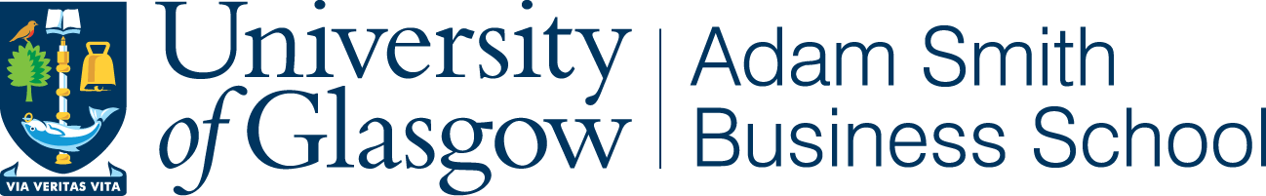 | 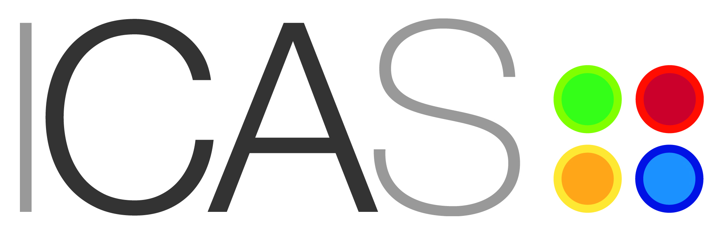
SCOTTISH DOCTORAL COLLOQUIUM IN ACCOUNTING AND FINANCE

Adam Smith Business School, University of Glasgow
Monday 1 June, 2015

We have pleasure in inviting doctoral students and their supervisors to the annual Scottish Doctoral Colloquium (ScotDoc) in Accounting and Finance, which will be held at the University of Glasgow on Monday 1 June, 2015.

This is a one-day meeting, comprising three plenary sessions and parallel presentation sessions. The presentations offer an opportunity for students at all stages of doctoral research in accounting or finance to present their work for comment by experienced academic supervisors from across the Scottish academic community. Presentations will be 15 minutes with around 5-10 minutes for discussion.

If you wish to present at this event:

Abstract submission (250 word limit)
Deadline: 20 April 2015
Submit to: ioannis.tsalavoutas@glasgow.ac.uk

Please include name, department/university,
supervisor, and year/primary area of study.
Notification of acceptance: by 4 May
Registration: by 18 May

Registration details will be provided in due course

If you have any questions about this event, please contact Dr. Ioannis Tsalavoutas from the University of Glasgow (email: ioannis.tsalavoutas@glasgow.ac.uk )

