40th Anniversary Management Control Conference – 18-19th June 2026
Call for papers

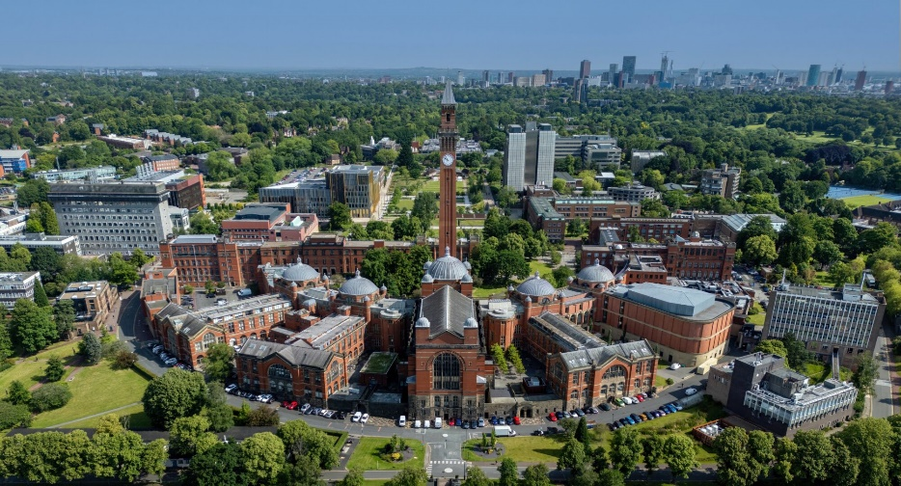 | Our 40th Anniversary Management Control (MCA) Conference will take place at Birmingham Business School, University of Birmingham, UK on 18-19th June 2026, with an emerging scholars colloquium on 17th June (see separate call).

Papers are invited on any aspect of management control or performance management. We especially welcome papers from an interdisciplinary perspective. Special themes:
- AI/digital developments in Management Control Systems (MCS)
- History of Management Accounting & MCS
- MCS for Sustainability, Nature, Earth & Beyond
- MCS for the Future
- Pragmatic Constructivism & Actor Reality
- Risk and Resilience as part of management accounting/control
- Strong Structuration Theory

Extended abstracts (see below) or full papers should be submitted to the scientific committee via the MCA website www.managementcontrolassociation.ac.uk by 28th February 2026: following the links to Conference 2026 and paper submission. Decisions will be sent out during March 2026. The file name should be in the format: abstracttheauthorssurname.docx (or pdf) or fullpapertheauthorssurname.docx (or pdf). 30th April 2026 is the deadline for full papers

Extended abstracts should be not more than 800 words, single line spaced. The title of the paper should be at the top of the page, with keywords, the author(s) name, affiliation, and contact details at the end (see advice on website).

Scientific Committee: Pr. Elena Giovannoni, Pr. Elaine Harris, Dr. Giulia Achilli, Dr. Melina Manochin, Dr. Anna Raffoni & Dr. Elina Varoutsa

